LAB 1 : INSTALL AGRO CD
Deploy EKS cluster
kubectl create namespace argocd
kubectl apply -n argocd -f https://raw.githubusercontent.com/argoproj/argo-cd/stable/manifests/install.yaml
Check:
kubectl get pods -n argocd
You should see components such as:
argocd-server
argocd-repo-server
argocd-application-controller
argocd-redis
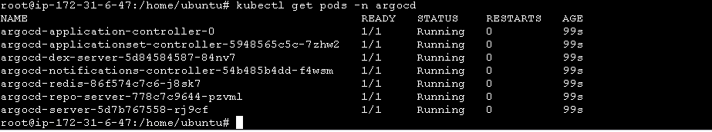
Step 2 — Open ArgoCD UI
kubectl port-forward svc/argocd-server -n argocd 8080:443
kubectl port-forward --address 0.0.0.0 svc/argocd-server -n argocd 8080:443
(Copy the public ip of the machine (eksctl machine) and https://publicip:8080 …also ensure to use https)

Open new cmd of the machine
Get password:
kubectl -n argocd get secret argocd-initial-admin-secret \
-o jsonpath="{.data.password}" | base64 -d; echo
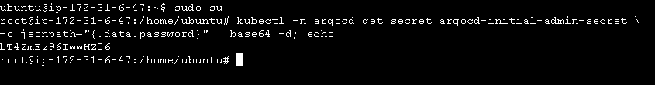
Login:
Username: admin
Password: <password>
